Section A: Lecture 7 Review
Review Lecture 7 and provide answers to the following questions in Week7.md in your Github Repository:
- What is image segmentation, and how does it relate with object detection?
Is a method in which a digital image is broken into various subgroups called image
segments. All picture elements or pixels belonging to the same category have a common label assigned to them. By segmenting the image, the model is able to detect the objects in the image.
- List at least two techniques of image segmentation you know and explain how they work.
Semantic Segmentation: by using deep neural networks to assign a specific category (like "car," "road," or "sky") to every single pixel in an image, creating a pixel-level understanding. It uses an encoder-decoder structure to downsample the image for feature extraction and then upsample it back to original size, resulting in a segmentation map where each pixel's color represents its identified class.
Instance segmentation: Instance segmentation works by combining object detection and semantic segmentation to identify, classify, and create a precise pixel-level mask for each individual object in an image, even distinguishing between multiple objects of the same type.
- What is image restoration? List at least two tasks of image restoration and explain techniques used to restore images in each tasks.

Image restoration uses models, often Convolutional Neural Networks (CNNs), to recover clean, high-quality images from corrupted or noisy versions by learning patterns of degradation (like blur, noise, low resolution) and reversing them, effectively filling in missing information or sharpening details to return the image to its original state.
- Inpainitng: is a core task within image restoration, focusing on reconstructing missing or damaged parts of an image by intelligently filling them with realistic content, making it appear seamless and original.
- Deblurring (or Deconvolution): Reversing the effects of blurring, which can be caused by camera motion, misfocus, or atmospheric turbulence.

Section B: Image Segmentation by Sobel filter

Step-by-Step Instructions:
- Review the Code:
  - The provided code performs edge detection on a grayscale image using the Sobel filter. The Sobel filter calculates the gradient of the image intensity in the x and y directions, which helps to detect edges.
- Complete the Code:
  - Complete the TODO part in the code, take screenshots of the part that you completed and include these screenshots in the file Week7.md in your GitHub repository.
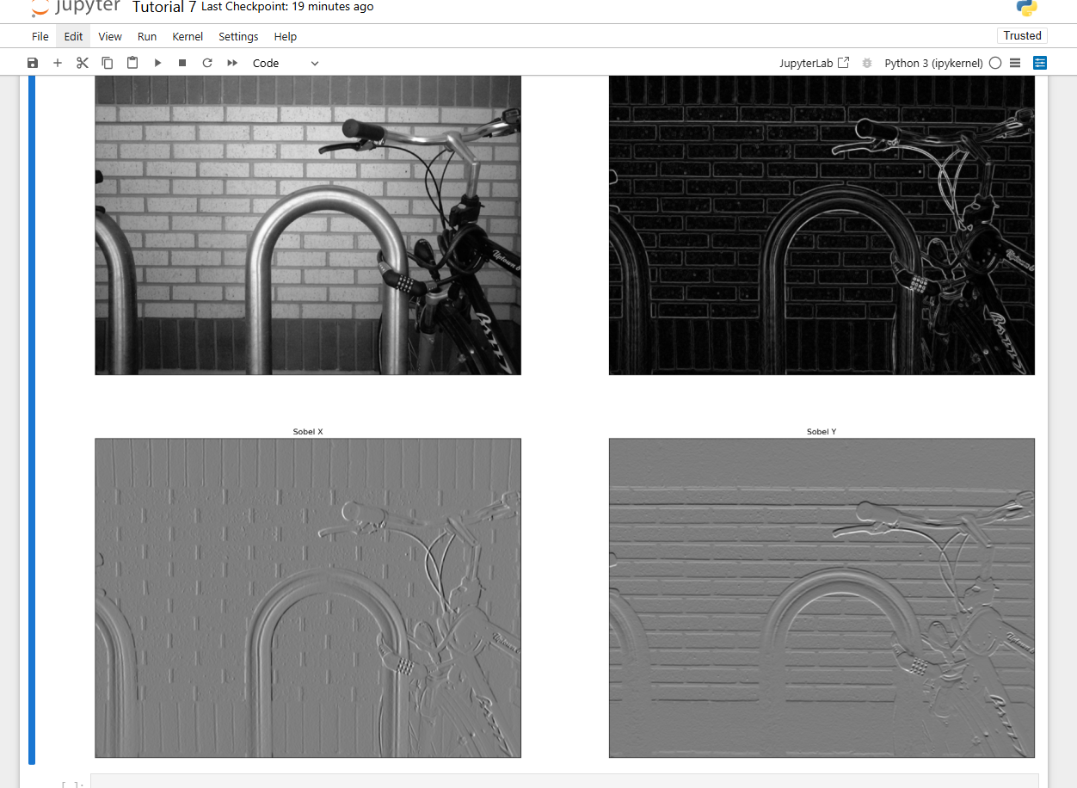
- Execute the Code:
  - Run the code provided to perform edge detection using the Sobel filter.
  - Result: The output should include the original image, the gradient magnitude image, and the images of the x and y gradients.
- Document and Comment on Results:
  - Take screenshots of the original image and the edge-detected images.
  - Include these screenshots in the file Week7.md in your GitHub repository.
  - Comment on the effectiveness of the Sobel filter in detecting edges.
The Sobel filter is effective at detecting edges in an image because it highlights regions with strong intensity changes, which usually correspond to object boundaries. However, the Sobel filter has limitations. It is sensitive to noise in highly textured or noisy images and can produce thick or blurred edges rather than precise boundaries. It also does not perform edge thinning or adaptive thresholding, so weaker edges may be missed while strong noise responses may still appear.
Sobel X and Sobel Y are not very effective on their own because they only detect edges in one direction and produce weak responses for edges at other orientations. Their output also includes negative values, which makes them harder to visualize. Combining both gradients produces a much clearer and more reliable edge map.

# Function to show multiple images
def show_images(images, cols=1, titles=None):
assert((titles is None) or (len(images) == len(titles)))
n_images = len(images)
if titles is None:
titles = ['Image (%d)' % i for i in range(1, n_images + 1)]

fig = plt.figure()
for n, (image, title) in enumerate(zip(images, titles)):
# Convert the number of columns to an integer
a = fig.add_subplot(cols, int(np.ceil(n_images/float(cols))), n + 1)
if image.ndim == 2:
plt.gray()
plt.xticks([])
plt.yticks([])
plt.imshow(image)
a.set_title(title)

fig.set_size_inches(np.array(fig.get_size_inches()) * n_images)
plt.show()

import cv2
import numpy as np
from scipy.signal import convolve2d
from matplotlib import pyplot as plt

def sobel_filter(img):

# TODO

return Gx, Gy, G

img = cv2.imread('bike.png',cv2.IMREAD_GRAYSCALE)
Gx, Gy, G = sobel_filter(img)
show_images([img, G, Gx, Gy], 2, ['Original', 'Sobel', 'Sobel X', 'Sobel Y'])

